**PA/Sound System Setup**

*Last Update: June 13, 2014*

The PA System is fairly easy to set up. **If it is raining please shut the system down (main unit and speakers) and place it in a dry area.**

**PREP WORK**

1. Run extension cords from the Little League field (behind home page) all the way along the fence, across the walkway and then along the softball fence.
2. When you plug it into the outlet, I would recommend first looping it around the fence and tying it into a knot. This will take the pressure off the plug/outlet and hopefully prevent it from inadvertently being unplugged.
3. Set up a small table next to the green box and place the sound system on top of it.

**AUDIO SETUP**

1. Remove the speakers from the main unit by pulling the snaps open
2. Each speaker can be removed from the unit and placed in the proper location. In the past we have placed one on top of the green box and the other on the other side of the green box facing up the hill.
3. Open the wire storage compartment on one side of the unit. Remove the wires.

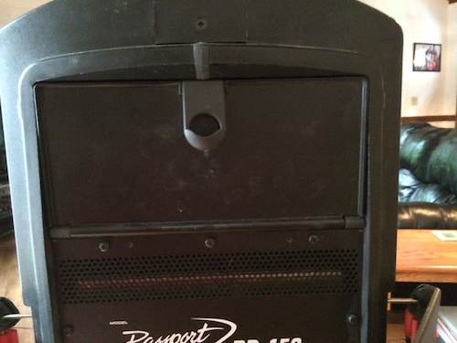

1. Run the speakers wire from the speaker to the unit. Each end of each speaker wire is the same and looks like this:

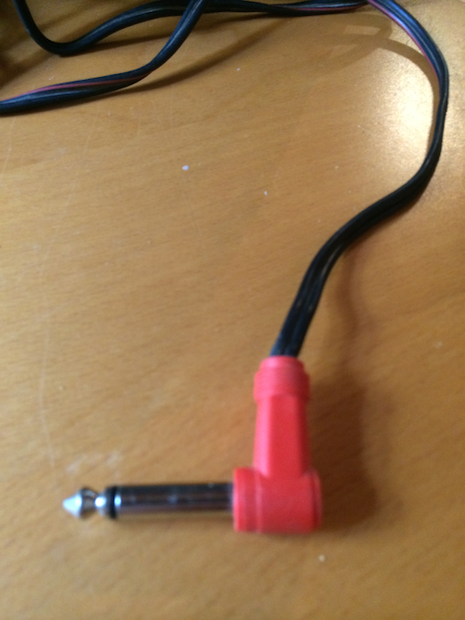

1. On the speaker, plug the speaker into the front:  
     
   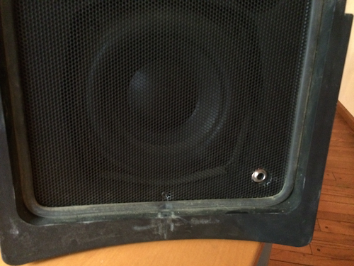
2. On the main unit, plug each speaker wire into the speaker jack as shown below:  
     
   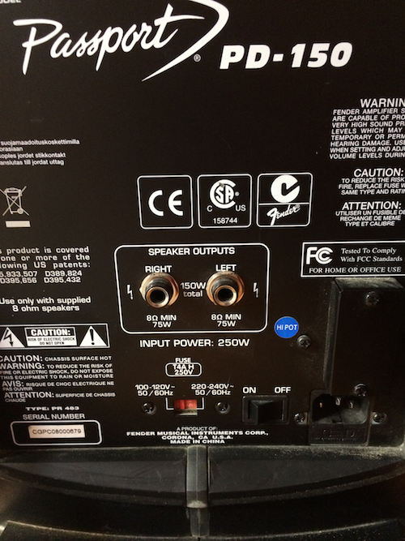
3. Plug the power cord in. It is on the bottom right if you are looking at the back of the unit. The on/off switch is located next to it. Once plugged in, turn the unit on.  
     
   
4. Plug the microphone wire into the XLR jack above channel input 1  
     
   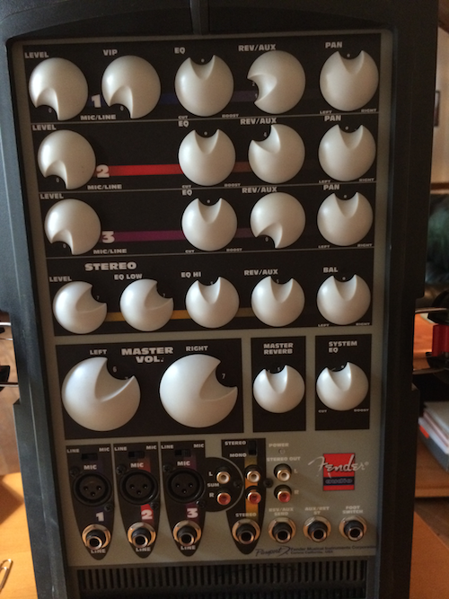
5. The other end of the XLR plugs into the microphone. The microphone has an on/off switch.
6. Plug the music audio cable into white and red jacks as indicated below.   
     
   
7. Plug the other end of the music audio cable into an iPhone or an iPod Touch.
8. Enjoy!

**VOLUME**



CONTROL MASTER VOLUME OF THE LEFT AND RIGHT SPEAKERS (EVERYTHING)

CONTROL VOLUME OF MUSIC

CONTROL VOLUME OF MICROPHONE